WHERE-TO-BE / WHAT-TO-DO
2025 SOLAR CAR CHALLENGE
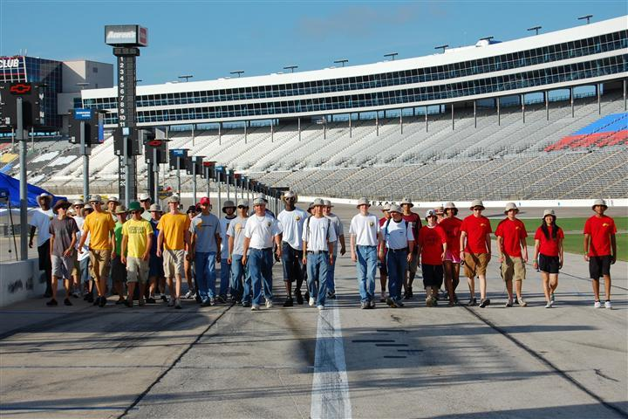

Monday
July 14
5:00 PM Interns Arrive for Training
San Marcos/Pecos Rooms, DFW Marriott & Golf Club

Tuesday
July 15
7:00 AM Intern Training Continues
San Marcos/Pecos Rooms, DFW Marriott & Golf Club

6:00 PM Dinner for Judges
Creekside, DFW Marriott & Golf Club

7:00 PM Judges Training
San Marcos/Pecos Rooms, DFW Marriott & Golf Club
[Designed to support Lockheed Martin Volunteers]

Wednesday
July 16 .
9:00 AM Judges Training Workshop [9:00 AM – 1:00 PM]
San Marcos/Pecos Rooms, DFW Marriott & Golf Club
[Lunch provided]

9:00 AM Team Check-In [9:00 AM – 5:00 PM]
Guadalupe/Brazos/Colorado Rooms, DFW Marriott & Golf Club
Teams will be assigned a time to arrive for Team Check-In based on their listing on the Team Profiles Page
https://www.solarcarchallenge.org/challenge/teams2024.shtml

Teams need to bring the following:
- SCC Release of Liability Form signed by parents
- TMS Release of Liability Forms (adult and minors)
- Signed Guidelines for Photographing/Filming
- Hard copy of all drivers’ licenses
[Wristbands awarded when driver completes Scrutineering Station 4]
- Purchase tickets for Opening & Awards Banquet - $65/person
- Pay Extra Person Fee (See Event Update No. 2025-1)
- Supply documents to complete Final Race Registration packet
- Bring radio you plan to use to coordinate channels

Teams will receive:
(1) 15 tee shirts
(2) 50 Official Race Booklets
(3) Traditional “baking soda” for environmental spills
(4) Rule Booklet and final “Where-to-Be What-to-Do” Document
(5) Official Scrutineering Packet
(6) Draw for 1st Day Starting Order, Garage Bay, Pit Row Location,
(7) Receive Number Decal to be placed on solar car
(8) Receive Banquet Tickets purchased prior to June 1st.
(9) Receive required Race Credentials

7:00 PM Required All-Teams Meeting – Trinity Ballroom
All race participants must attend

7:45 PM Drivers Meeting
Team Advisers and Drivers must attend.
Guadalupe/Brazos Rooms

Thursday
July 17
6:30 AM Judges Meet at Garages for Scrutineering

7:00 AM Scrutineering Day One
Teams get access to Texas Motor Speedway. Staff will show
teams their designated garage and pit row space .

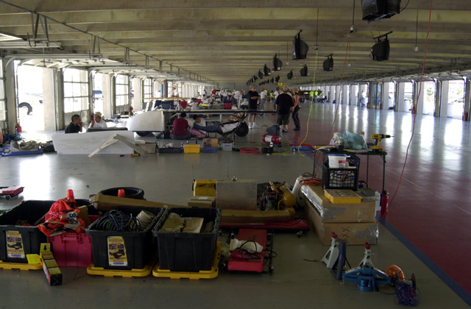

8:00 AM Scrutineering Session No. 1 [8:00 AM – 6:00 PM]
Teams begin Scrutineering

Teams will meet with Judges for 5-minute discussion about their
Solar Car Project. Details for this oral presentation, including scheduling, will be available in Event Update No. 2025-5.

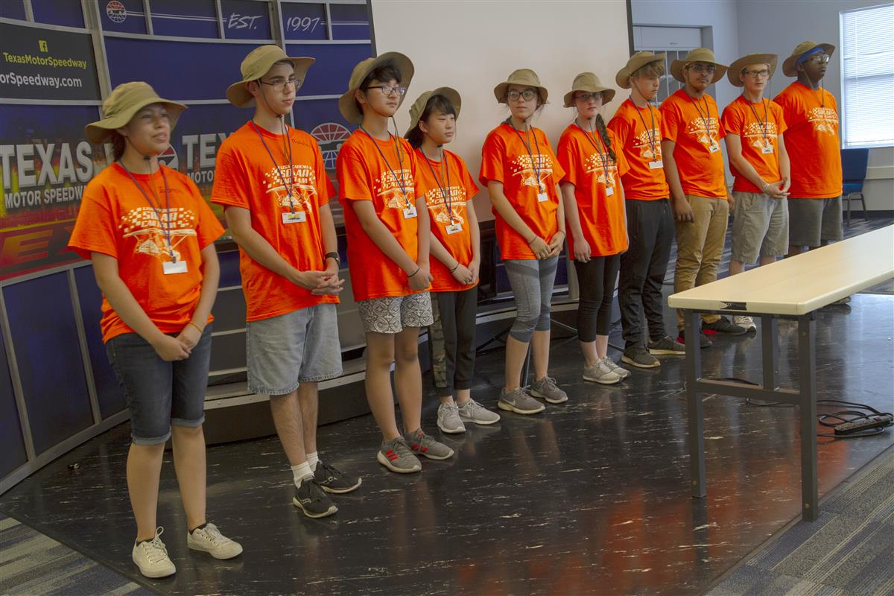

6:00 PM Scrutineering Session No. 1 Ends
Garages will remain open until 9:00 PM so that teams can continue working on solar cars.

7:30 PM OPENING BANQUET
Trinity Ballroom, DFW Marriott Ballroom
Team Captains will introduce their teams and guests.
Race Credentials required for admission to Opening Banquet

9:00 PM Garage Closes

Friday
July 18
6:30 AM Judges meet at Garages for Scrutineering

7:00 AM Scrutineering Day Two
Teams get access to Texas Motor Speedway

8:00 AM Scrutineering Session No. 2 [8: 00 AM – 7:00 PM]

10:00 AM Media Morning Activities [10:00 AM – 11:30 AM]
Teams will assemble next to the Media Center for the Official Race
Photo, and to officially recognize Race Sponsors. Ice Cream will be
provided afterwards. Music provided by Dallas Brass Band.

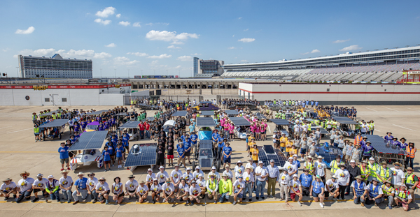

7:00 PM Scrutineering Session No. 2 Ends
Garages will remain open until 9:00 PM so that teams can continue working on solar cars.

7:30 PM Judges Meeting
Creekside Room, DFW Marriott
Saturday
July 19
6:30 AM Judges meet at Garages for Scrutineering

7:00 AM Scrutineering Day Three
Teams get access to Texas Motor Speedway

8:00 AM Scrutineering Session No. 3 [8: 00 AM – 8:00 PM]
Teams not qualifying by 8:00 PM will not be able to take part
in the 2025 Solar Car Challenge.

8:00 PM Official Scrutineering Ends
Race Staff is on their own for Dinner

9:00 PM Garages Close
Sunday
July 20
6:30 AM Teams get access to Texas Motor Speedway.
Judges will meet teams at the CUP Garage.

8:00 AM Required Teams Meeting
West End of CUP Garage

8:45 AM Solar Cars lined up in pit row for RACE START
Starting Order based on Team Check-In Drawing. Teams start racing every minute. Any team not ready at their prescribed time will take a position at the end of the Starting Order Line.

8:50 AM OPENING CEREMONIES
Music provided by Dallas Brass Band.

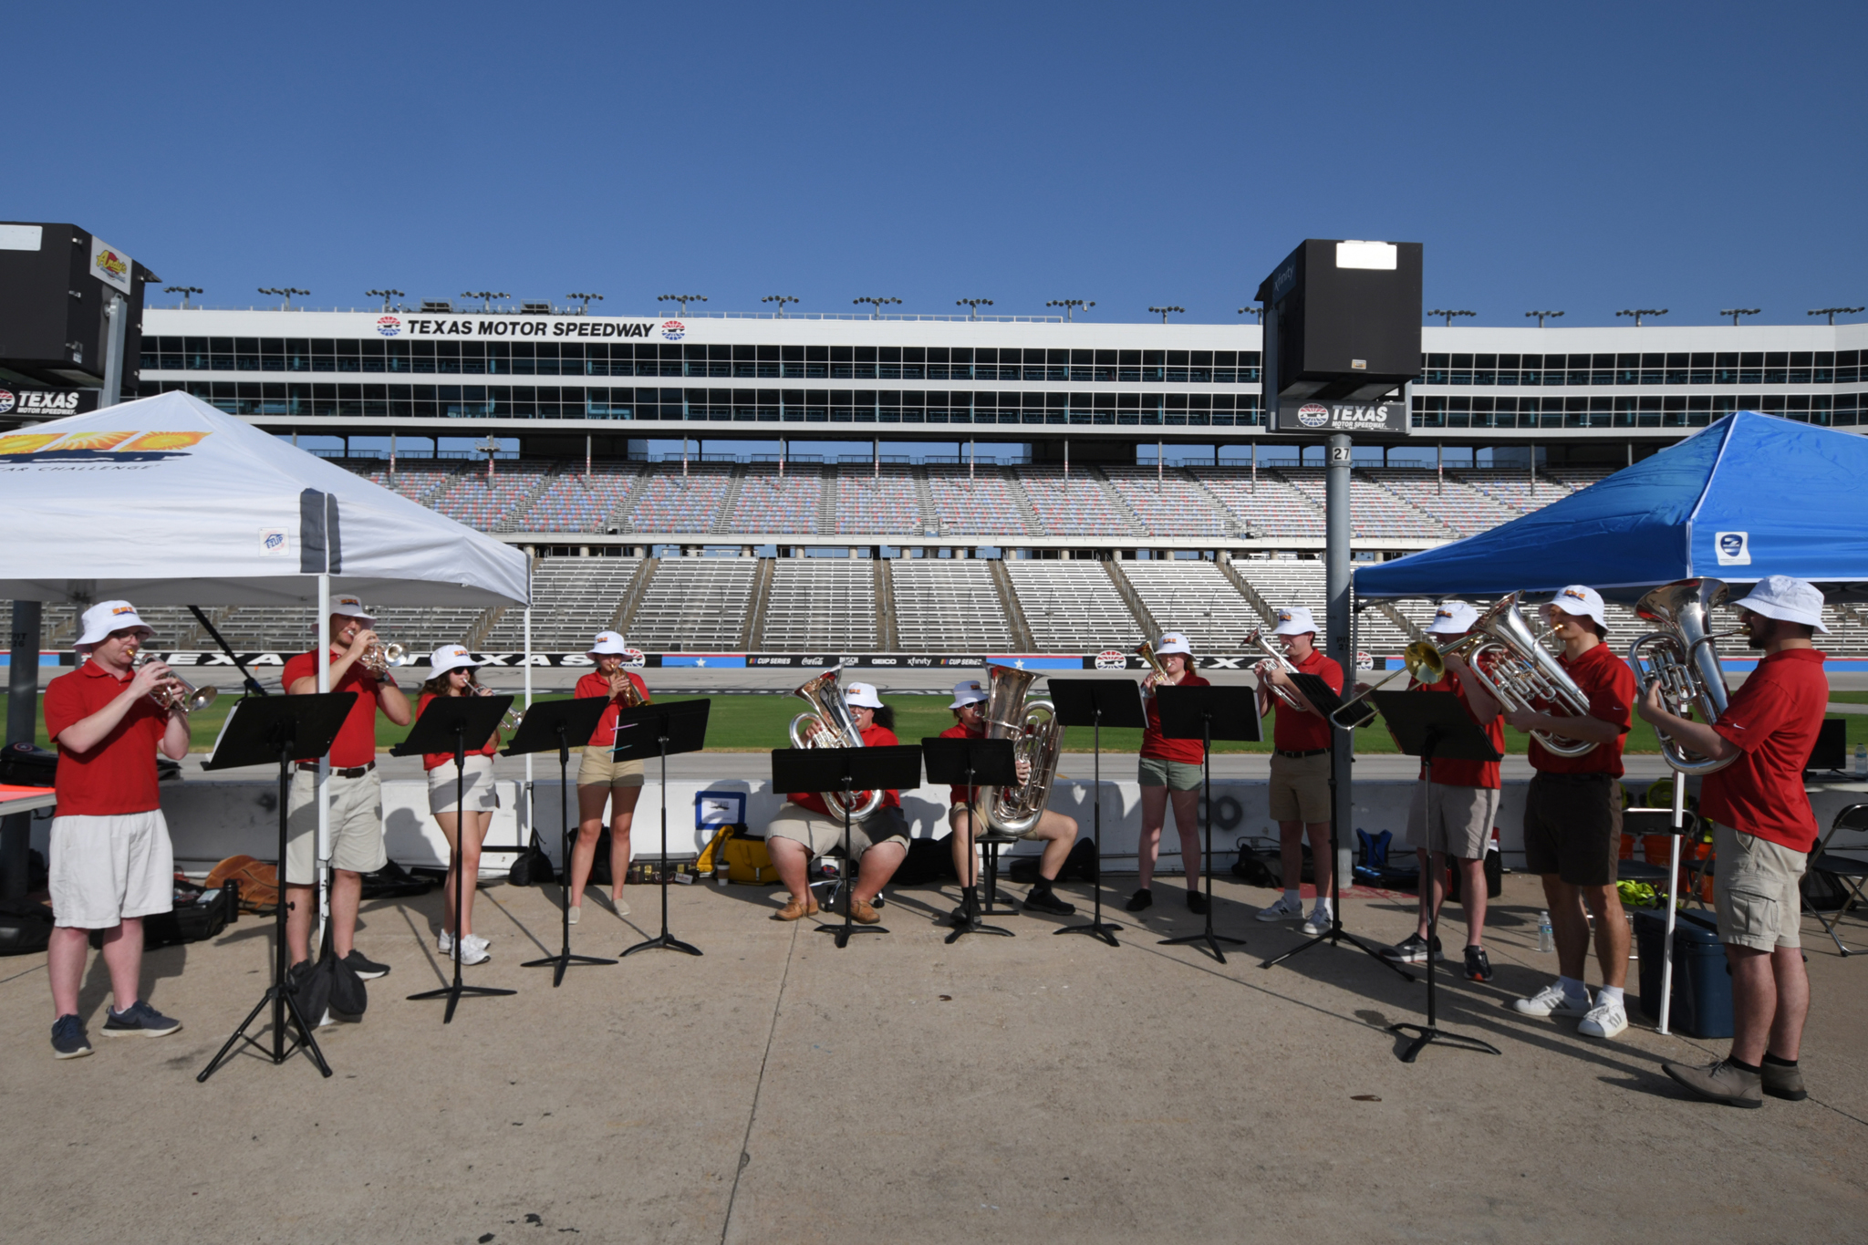

9:00 AM FIRST RACE DAY BEGINS – All Divisions
RACING PERIODS:
Classic Division, Advanced Classic Division, and Electric-Solar Power Division vehicles will race from 9:00 AM – 12:00 PM, and 2:00 PM – 5:00 PM. The Advanced Division and Cruiser Division vehicles will race from 9:00 AM – 5:00 PM with a required 30 minutes off-track rest period. Teams must use all of their 30 minutes at one time.

10:00 AM Forever Laps posted on Media Center Auditorium Door

12:00 PM End of racing for Classic Division, Advanced Classic, and Electric-Solar Powered Division vehicles

1:45 PM Classic, Advanced Classic, and Electric Vehicles lined up in pit row for Re-Start

2:00 PM Racing resumes for Classic Division, Advanced Classic Division, and Electric-Solar Powered vehicles

5:00 PM END RACING DAY FOR ALL VEHICLES.
Teams leave track in staggered order based on Starting Order

6:30 PM Judges Dinner – Media Center

7:00 PM Judges Meeting – Media Center

9:00 PM Vehicles Impounded in Texas Motor Speedway Garages.
Monday
July 21
6:30 AM Teams get access to Texas Motor Speedway.
Judges will meet teams at the CUP Garage.

8:00 AM Required Teams Meeting
West End of CUP Garage

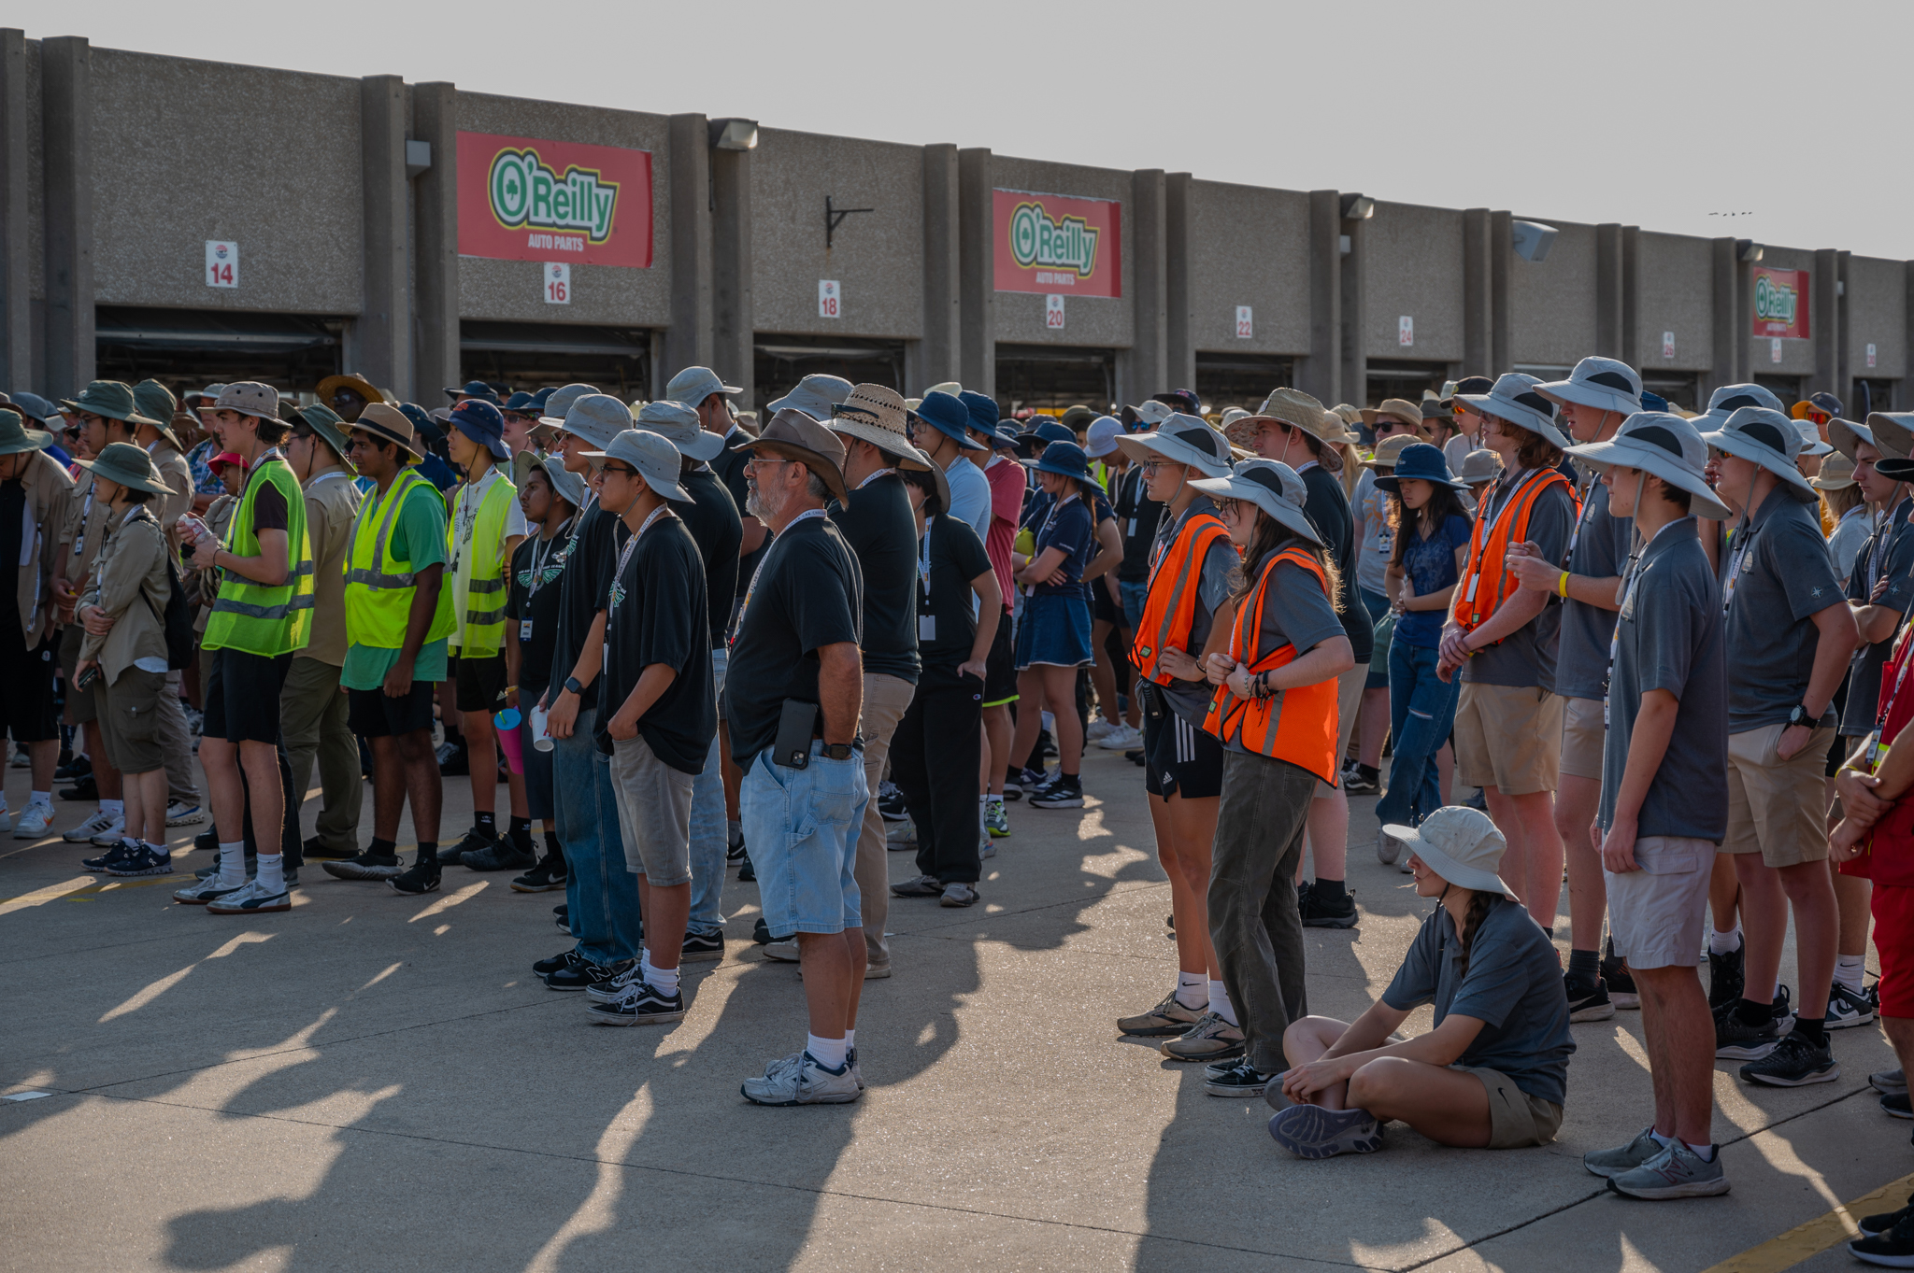

8:45 AM Solar Cars lined up in pit row for RACE START
The Starting Order in each division will be based on the official number of laps earned during the preceding day of racing. Teams start racing every minute. Any team not ready at their prescribed time will take a position at the end of the Starting Order Line.

9:00 AM SECOND RACE DAY BEGINS – All Divisions

12:00 PM End of racing for Classic Division, Advanced Classic Division, and Electric-Solar Powered vehicles

1:45 PM Classic, Advanced Classic, and Electric Vehicles lined up in pit row for Re-Start

2:00 PM Racing resumes for Classic Division, Advanced Classic Division, and Electric-Solar Powered vehicles

5:00 PM END RACING DAY FOR ALL VEHICLES.
Teams leave track in staggered order based on Start Order

6:30 PM Judges Dinner – Media Center

7:00 PM Judges Meeting – Media Center

9:00 PM Vehicles Impounded in Texas Motor Speedway Garages.

Tuesday
July 22
6:30 AM Teams get access to Texas Motor Speedway.
Judges will meet teams at the CUP Garage.

8:00 AM Required Teams Meeting
West End of CUP Garage

8:45 AM Solar Cars lined up in pit row for RACE START
The Starting Order in each division will be based on the official number of laps earned during the preceding day of racing. Teams start racing every minute. Any team not ready at their prescribed time will take a position at the end of the Starting Order Line.

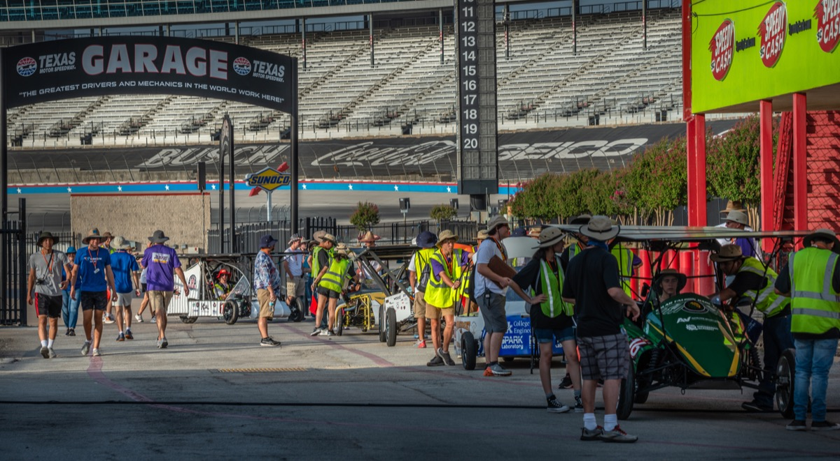

9:00 AM THIRD RACE DAY BEGINS – All Divisions

12:00 PM End of racing for Classic Division, Advanced Classic Division, and Electric-Solar Powered vehicles

1:45 PM Classic, Advanced Classic, and Electric Vehicles lined up in pit row for Re-Start

2:00 PM Racing resumes for Classic Division, Advanced Classic, and Electric-Solar Powered vehicles

5:00 PM END RACING DAY FOR ALL VEHICLES.
Teams leave track in staggered order based on Start Order

6:30 PM Judges Dinner – Media Center

7:00 PM Judges Meeting – Media Center

9:00 PM Vehicles Impounded in Texas Motor Speedway Garages

Wednesday
July 23
6:30 AM Teams get access to Texas Motor Speedway.
Judges will meet teams at the CUP Garage.

8:00 AM Required Teams Meeting
West End of CUP Garage

8:45 AM Solar Cars lined up in pit row for RACE START
The Starting Order in each division will be based on the official number of laps earned during the preceding day of racing. Teams start racing every minute. Any team not ready at their prescribed time will take a position at the end of the Starting Order Line.

9:00 AM FOURTH RACE DAY BEGINS – All Divisions

12:00 PM End of racing for Classic Division. Advanced Classic Division, and Electric-Solar Powered vehicles

1:45 PM Classic, Advanced Classic, and Electric Vehicles lined up in pit row for Re-Start

2:00 PM Racing resumes for Classic Division and Electric-Solar
Powered vehicles

4:00 PM END RACING DAY FOR ALL VEHICLES.
Teams leave track in staggered order based on Start Order

5:00 PM Teams must leave Texas Motor Speedway.
Everything must be out of the Garages by 5:30 PM.

TURN IN RADIOS AS YOU EXIT THE SPEEDWAY
Race Staff will get radios as you exit through the South Gate

7:30 PM AWARDS BANQUET
Trinity Ballroom, DFW Marriott & Golf Club

Team Captains will be called on to share their race experiences. Be prepared to make a
one-minute speech!

